TASK 1

#include <iostream>

using namespace std;

int main()

{

int sum = 0;

for (int i = 1; i<=50; i++) {

int factors=0;

for (int j=1; j<=i; j++) {

if (i%j==0) {

factors++;

}

}

if (factors == 2) {

sum += i;

}

else {

continue;

}

}

cout<<"Sum of prime numbers from 1 to 50 is"<<sum<<endl;

}

TASK 2

#include <iostream>

using namespace std;

int main() {

for (int i = 1; i <= 5; i++) {

for (int j = 1; j <= i; j++) {

cout << j << " ";

}

cout << endl;

}

return 0;

}

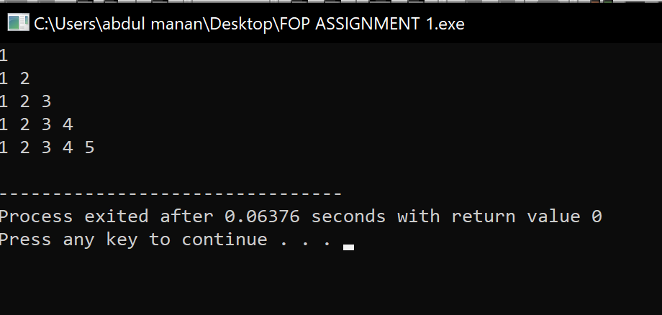\

TASK 3

#include <iostream>

using namespace std;

int main() {

int n = 2;

cout<<"1"<<endl;

for (int i = 1; i <= 8; i+=2) {

for (int j = 0; j <= i; j++) {

cout << n << " ";

}

n += 2;

cout << endl;

}

return 0;

}

